Project 1: Personal Profile

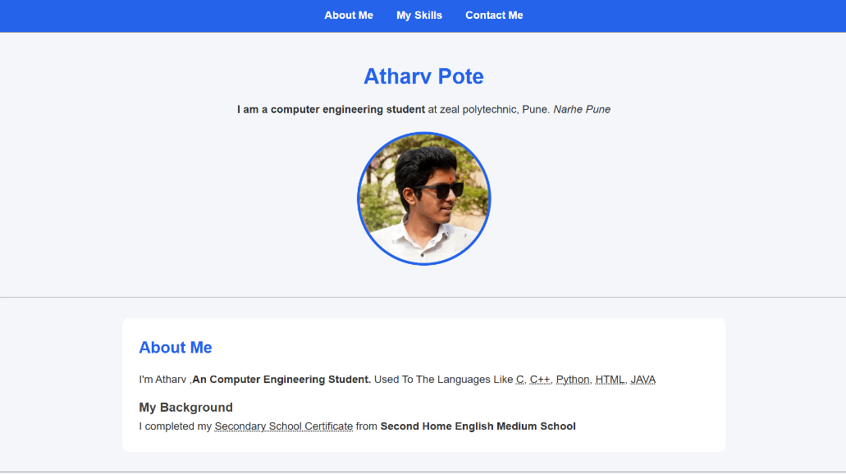

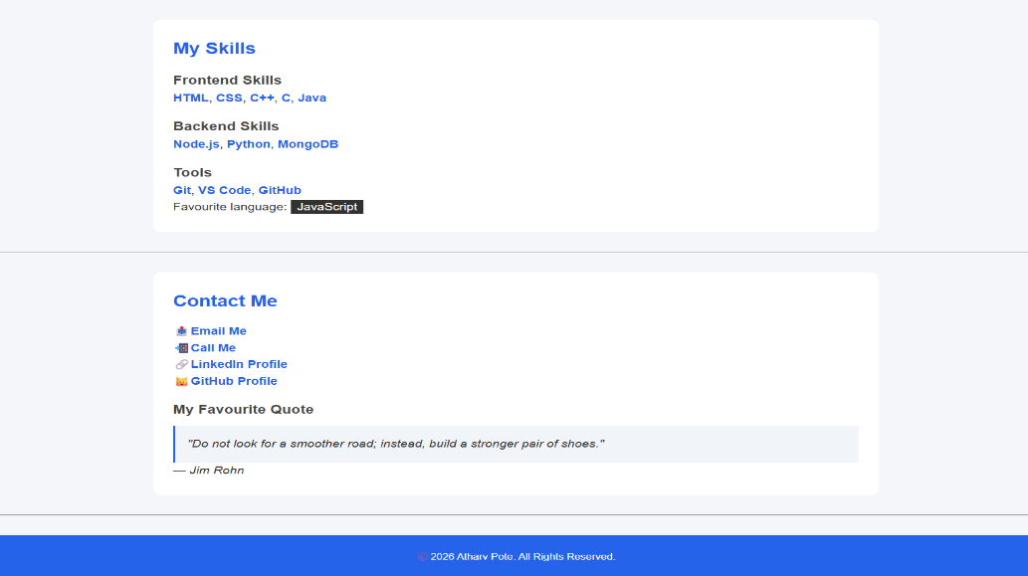

Problem: Creating your personal profile using HTML & CSS

Project 2: Web Project (Multiple Pages)



Problem: Creating Your First Web Project with Multiple Pages
Topic For Web Project: Real E-State Website

Project 3: Calculator App

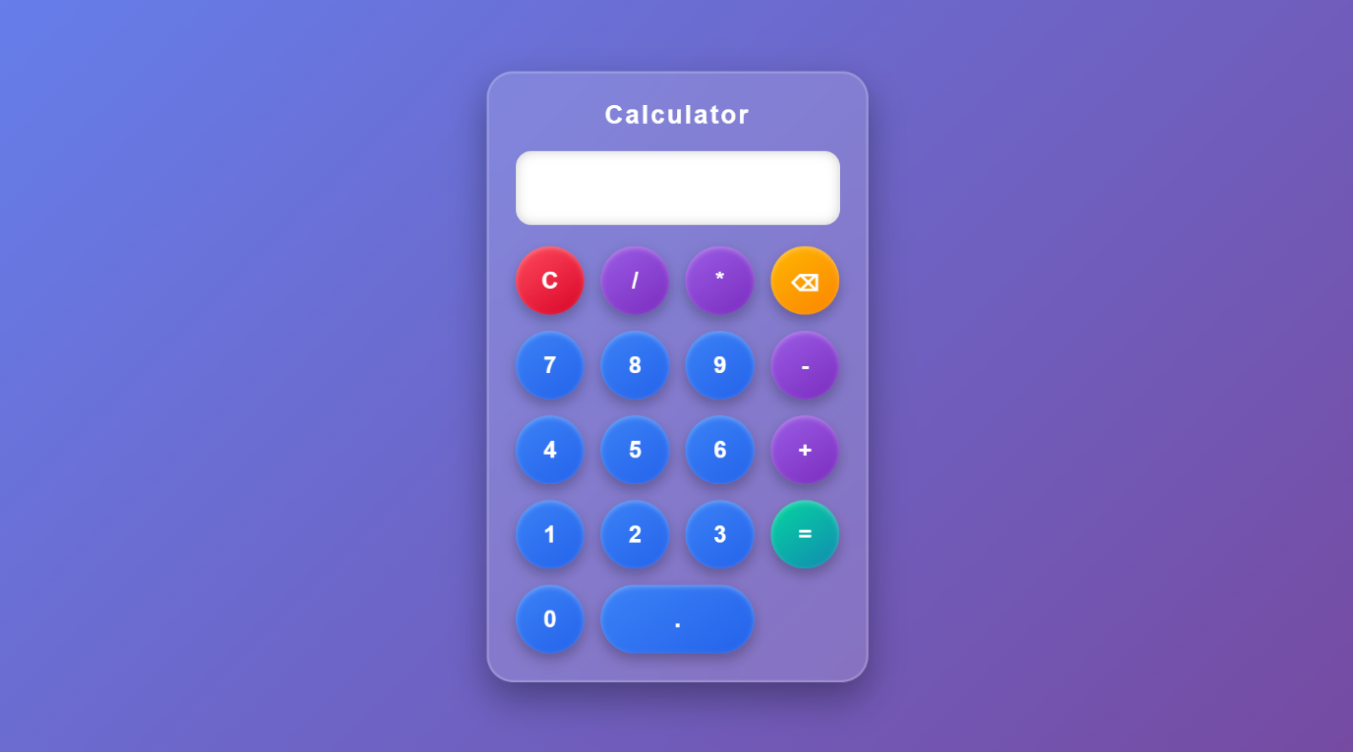

Problem: Create a Calculator App using Java Script (Js)

Project 4: Calculator App

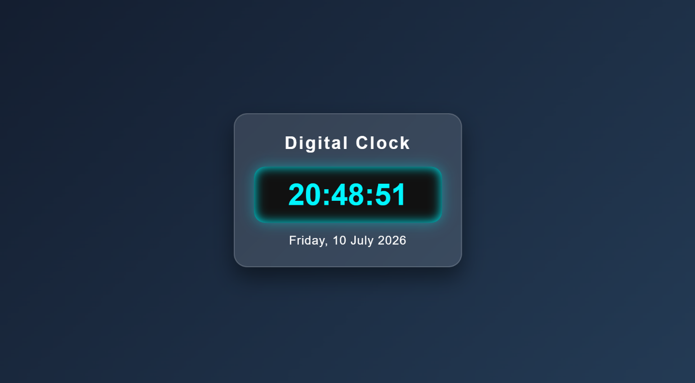

Problem: Create a Date & Time App, showing the live date and time

Project 5: First React App

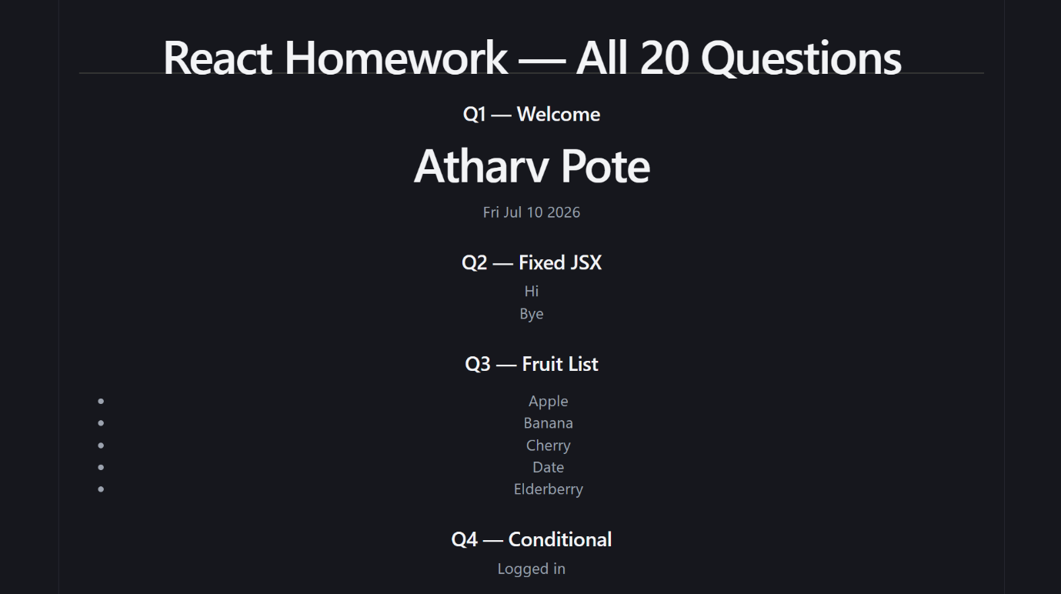

Problem: Create an first web app using React And Js, & complete homework

Project 6: First React App

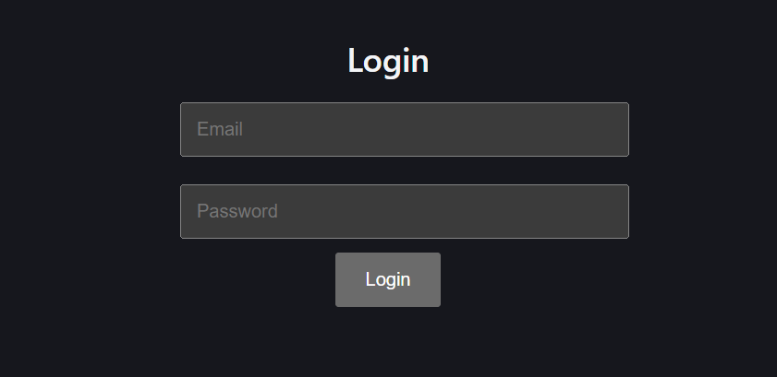

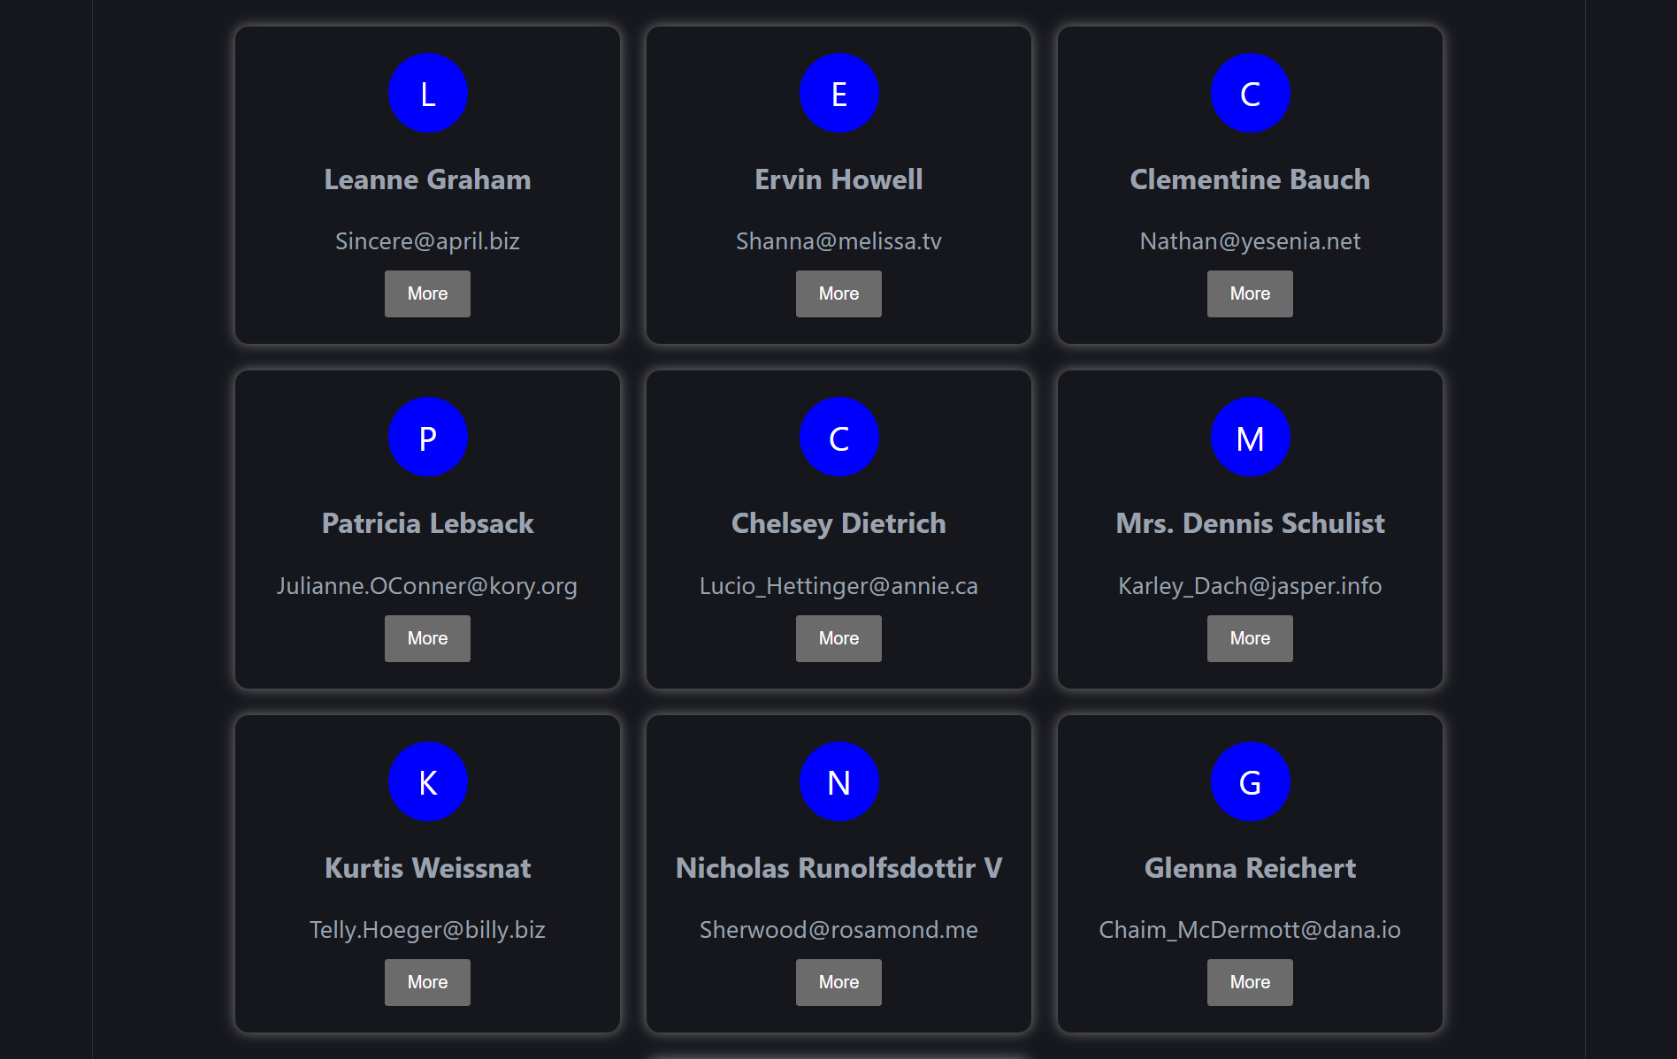

Problem: Develop a React User Dashboard with a login page, fetch user data from an API, display user cards, and implement loading, error handling, and custom CSS styling.

